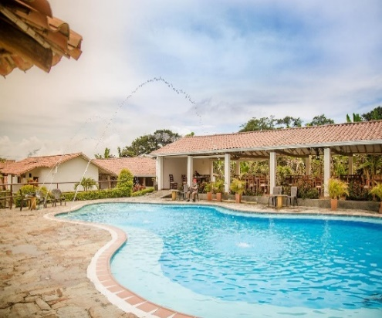
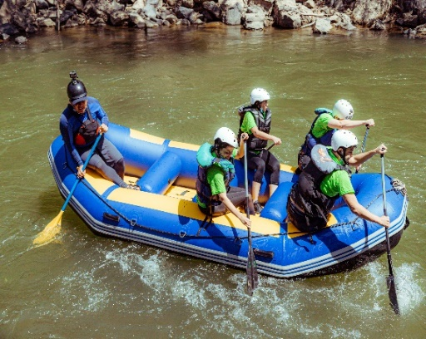
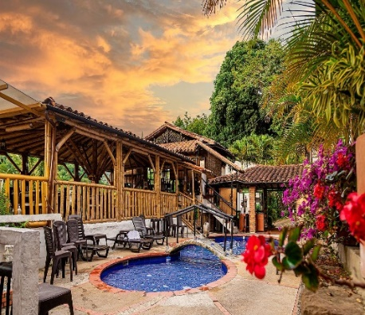
5n/6d
Great Adventure in Santander

Hotel en Bucaramanga | Tourist Hotel
Hotel in Oiba | Hacienda Guane
Hotel in San Gil | Terrazas de la Candelaria

►PLAN INCLUDES:

- Accommodation at the Hotel de Bucaramanga (1 night)
- Accommodation at the Hotel Hacienda Guane (2 nights)
- Accommodation at the Hotel de San Gil - Hotel Terrazas (2 nights)
- Taxes and hotel insurance
- Airport–hotel–airport transfer (permanent transportation)
- Transfer from Chicamocha National Park to Hotel San Gil or Barichara
- Breakfasts at the hotel, dinners
- Visit to Villa de los Caballeros waterfall
- Alférez Canyon or Quebrada de la Vega route
- City Night Tour – Cerro El Santísimo (Visit to the tallest illuminated cable-stayed bridge within a city in Colombia)
- Tour Crossing the Chicamocha
- Tour San Gil, Barichara, Curití
- Tour to Oiba Guadalupe and the gachas
- Paragliding
- Canoeing
- 13 activities circuit
- Medical assistance

NOT INCLUDED

- Expenses not specified in the program
ITINERARY

Day 1
- Airport Transfer – Hotel – We suggest (Arrival must be before 2 PM.)
- Paragliding
- City Night Tour, Permanent Transportation, Tour Guide, visit to Girón National Monument, visit to Floridablanca, Entrance to Ecopark, Cable Car Ride to Cerro El Santísimo, vsit to the tallest illuminated cable-stayed bridge within a city in Colombia
- Dinner
- Accommodation in Bucaramanga

Day 2
- Breakfast at the hotel.
- Tour crossing Chicamocha (Departure: 7:45 a.m. Hotel lobby, visit to the farmers' market in Mesa de los Santos, refreshments, entrance to Chicamocha National Park via the “Plazuela” station, total cable car ride 6.3 km (one way) where you can see the wonderful canyon, tour of the park facilities.
- Visit and entrance to LAS GACHAS NATURAL ATTRACTION.
- Dinner.
- Accommodation at Hotel Hacienda Guane

Day 3

- Breakfast at the hotel.
- Entrance to Alferez Canyon or Quebrada de la Vega Route, depending on choice (depens on weather) Villa de los Caballeros Waterfall.
- Dinner.
- Accommodation at Hotel Hacienda Guane

Day 4

- Breakfast at the hotel.
- Departure: 7:30 a.m.
- Visit Oiba, a small nativity scene village
- Visit Socorro, the capital of the community.
- Visit Pinchote.
- Visit Barichara, the most beautiful village in Colombia.
- Dinner.
- Accommodation in San Gil at Hotel Terrazas La Candelaria.

Day 5

- Breakfast at the hotel
- Departure at 7:30 a.m.
- Canoeing
- 13-activity circuit
- Dinner
- Accommodation at San Gil Hotel Terrazas La Candelaria

Day 6

- Breakfast
- Day off to enjoy the hotel
- Visit to Curiti
- Hotel-airport transfer (we suggest the return to be after 3 pm)

Circuit 13 activities:

1. Flying cable
2. Caving
3. Underwater dragging
4. Leap into the void
5. Hiking
6. Water crossing
7. Ecological walk
8. Spider web
9. Canopy tour
10. Log bridge
11. Dancing bridge
12. Himalayan bridge
13. Quick Jump: leap of faith…unique in the country!

Included

Professional guide
Personal protective equipment
Medical insurance

Recommendation

✅ Comfortable, sporty clothing that can get wet, and sneakers.
✅ Bring essentials such as money, cell phones, and a change of clothes.
✅ The walking trail facilities have showers.

Important

If activities are omitted at the customer's request, no refund will be given unless weather conditions prevent the activity from taking place. In this case, the customer may reschedule the activity.

RATES PER PERSON
HOTEL | MULTIPLE | DBL | SGL | KIDS  (5 a 10 )
TOURIST | $435 | $448 | $474 | $395
*All departures are shared (excursion type)*

INFANT FARE
AGE | PRICE | INCLUDES
0 a 2 | $ 8 | Medical Assistance
3 a 4 | $ 56 | Medical assistance, attraction tickets, and transportation
*Infant fare NOT commissionable *

RECOMMENDATIONS DURING THE TOUR

To ensure you enjoy your experience to the fullest on this tour, we would like to share the following recommendations with you:

- Bring sunscreen
- Bring a cap or hat
- Bring cool clothing and comfortable shoes
- Bring a swimsuit to enter the water park
- Bring a change of clothes for after canyoning (additional cost)
- Driver's license to enter the buggies (additional cost)
- Bring a camera
- Bring water
- To help preserve the environment, we recommend disposing of waste in a trash can.

