4n/5d
Adventure in Santander
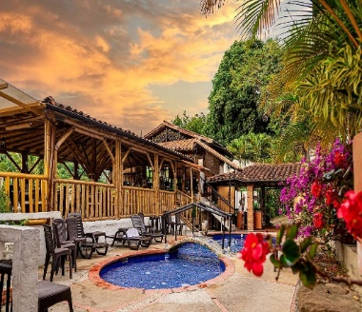
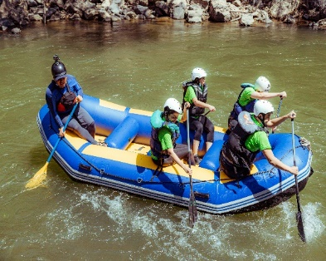
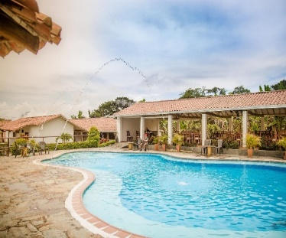

Hotel en Bucaramanga | Tourist hotel
Hotel in Oiba | Hacienda Guane
Hotel in San Gil | Terrazas de la Candelaria

► PLAN INCLUDES:

- Accommodation at the Hotel de Bucaramanga (1 night)
- Accommodation at the Hotel Hacienda Guane (1 night)
- Accommodation at the Hotel de San Gil Hotel Terrazas de la Candelaria (2 nights)
- Taxes and hotel insurance
- Airport–hotel–airport transfer (permanent transportation)
- Chicamocha National Park –Hotel San Gil or Barichara transfer
- Breakfast at the hotel, dinners
- City Night Tour–Cerro El Santísimo (visit to the longest illuminated cable-stayed bridge in South America)
- Tour Crossing the Chicamocha
- Tour San Gil, Barichara, Curití
- Tour to Oiba Guadalupe and Las Gachas
- Paragliding
- Rafting
- 13 Activities Circuit
- Medical Assistance

NOT INCLUDED

- Expenses not specified in the program

ITINERARY

Day 1
- Airport Transfer – Hotel – We suggest (Arrival must be before 2 PM.)
- Paragliding
- City Night Tour, Transportation, Tour Guide, Visit to Girón National Monument, Visit to Floridablanca, Entrance to Ecopark, Cable Car Ride to Cerro El Santísimo, Visit to the tallest illuminated cable-stayed bridge within a city in Colombia
- Dinner
- Accommodation in Bucaramanga

Day 2
- Breakfast at the hotel.
- Leave your luggage at the hotel reception in Bucaramanga. For your convenience, we will collect it and take it to the hotel in San Gil. Only take what you need for the day on the tour.
- Tour crossing Chicamocha (Departure: 7:45 a.m. from the hotel lobby, visit to the farmers' market in Mesa de los Santos, refreshments, Entrance to Chicamocha National Park via the “Plazuela” station, total cable car ride 6.3 km (one way) where you can see the wonderful canyon, tour of the park facilities).
- Departure for Guadalupe, approximately 3:30 pm
- Visit and tour of CURITI “ARTESANIAS EN FIQUE”
- Dinner
- Accommodation at Hotel Hacienda Guane

Day 3
- Breakfast at the hotel.
- Departure: 7:30 a.m.
- Visit and admission to LAS GACHAS NATURAL ATTRACTION.
- Visits and sightseeing tours of GUADALUPE and its churches.
- Visit to Oiba, a small nativity scene village
- Visit to Socorro, Capital Comunera
- Visit to Barichara, the most beautiful village in Colombia
- Dinner
- Accommodation in San Gil, Hotel Terrazas de la Candelaria.

Day 4

- Breakfast at the hotel
- Departure at 8:30 a.m.
- Circuit of 13 activities
- Dinner
- Accommodation in San Gil, Hotel Terrazas de la Candelaria.
Day 5

- Breakfast
- Day off to enjoy the hotel
- Hotel-airport transfer (we suggest that the return flight be after 3 pm)

Circuit 13 activities:

- Flying cable
- Caving
- Underwater dragging
- Leap into the void
- Hiking
- Water crossing
- Ecological walk
- Spider web
- Canopy tour
- Log bridge
- Dancing bridge
- Himalayan bridge
- Quick Jump: leap of faith…Unique in the country!

Includes:

- Professional guide
- Personal protective equipment
- Medical insurance

Recommendation

- Comfortable, sporty clothing that can get wet, and sneakers.
- Bring essentials such as money, cell phones, and a change of clothes.
- The hiking facility has showers.

Important

If the customer decides to skip any activities, no refund will be given, unless weather conditions prevent the activity from taking place. In this case, the customer may reschedule the activity.

RATES PER PERSON
HOTEL | MULTIPLE | DBL | SGL | KIDS  (5 a 10 )
TOURIST | $340 | $356 | $382 | $300
*All departures are shared (excursion type)*

INFANT FARE
AGE | PRICE | INCLUDES
0 a 2 | $ 8 | Medical Assistance
3 a 4 | $ 56 | Medical assistance, attraction tickets, and transportation
*Infant fare NOT commissionable*

RECOMMENDATIONS DURING THE TOUR

To ensure you enjoy your experience to the fullest on this tour, we recommend the following:

- Bring sunscreen
- Bring a cap or hat
- Wear cool clothing and comfortable shoes
- Bring a change of clothes for after rappel (additional cost)
- Driver's license to enter the buggies (additional cost)
- Camera
- Bring water
- To contribute to the conservation of the environment, we recommend depositing waste in a trash can.

