MOVING AROUND SANTANDER 6N/7D
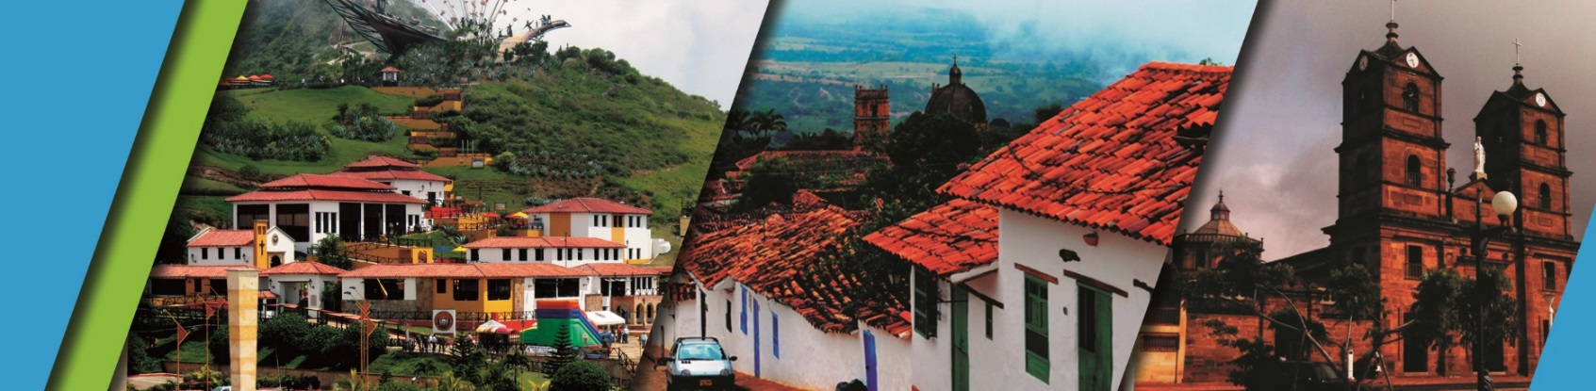

PLAN INCLUDES:

- Accommodation at the Hotel in Bucaramanga (3 nights)
- Accommodation at the Hotel in San Gil or Barichara (1 night)
- Accommodation at the Hotel in Oiba (2 nights)
- Taxes and hotel insurance
- Airport–hotel–airport transfer
- Chicamocha National Park–San Gil or Barichara hotel transfer
- 6 breakfasts at the hotel, 6 dinners, 5 lunches
- City Night Tour – Cerro El Santísimo (regular departure – park closed on Mondays)
- Tour Crossing the Chicamocha (regular departure - park is closed on Mondays and Tuesdays)
- San Gil Tour, Barichara Tour, Curití Tour (regular departure)
- Socorro Tour, Valle San José Tour, Pinchote Tour (regular departure)
- Las Gachas Tour
- Visit to Socorro
- Visit to Oiba
- Visit to Guadalupe
- Zapatoca Tour (regular departure)
- Visit to Las Gachas
- Visit to Oiba
- Medical assistance

NOT INCLUDED

- Expenses not specified in the program

ITINERARY
Day 1
- Airport transfer to hotel
- Breakfast at the hotel
- Free morning
- City Night Tour (Departure: 3:30 pm Hotel Lobby, Permanent Transportation, Tour Guide, Travel Insurance, Visit to Girón National Monument, Visit to Floridablanca, local snack Tasting, Entrance to Ecopark, Cable Car Ride to Cerro El Santísimo, Visit to the tallest Cable-Stayed Bridge within a city in Colombia)
- Dinner
- Accommodation in Bucaramanga

Day 2

- Breakfast at the hotel.
- Leave your luggage at the hotel reception in Bucaramanga. For your convenience, we will collect it and take it to the hotel in San Gil or Barichara. Take only what you need for the day on the tour.
- Tour Crossing Chicamocha (Departure: 7:45 a.m. Hotel lobby, visit to the farmers' market in Mesa de los Santos, refreshments, Entrance to Chicamocha National Park via the “Plazuela” station, total cable car ride 6.3 km (one way) where you can observe the wonderful canyon, tour of the park facilities and typical regional lunch).
- Departure for Oiba, approximately 3:30 pm
- Dinner
- Accommodation in Oiba

Day 3
- Breakfast at the hotel
- Visit and admission to LAS GACHAS NATURAL ATTRACTION
- Visits and sightseeing tours of GUADALUPE and its churches.
- Visit to Oiba, the nativity scene village
- Visit to Socorro, the community capital
- Dinner
- Accommodation in Oiba

Day 4
- Breakfast at the hotel
- Sightseeing tour of PINCHOTE, home of Antonia Santos
- Lunch
- Sightseeing tour of VALLE DE SAN JOSÉ
- Degustación de los “CHORIZO DOÑA EUSTAQUIA”
- Dinner
- Accommodation in San Gil

Day 5
- Breakfast at the hotel
- Visit and tour of CURITI
- Visit and admission to EL GALLINERAL NATURAL PARK
- Transfer to BARICHARA
- Lunch in BARICHARA
- Visits and sightseeing tours of BARICHARA and its churches
- Dinner
- Accommodation in Bucaramanga

Day 6
- Breakfast at the hotel.
- Crossing the 500-meter-long Gómez Ortiz Bridge over the Hidrosogamoso Dam. Tourist route “La Ciudad Levítica” (The Levitical City), entrance to the Church of San Joaquín.
- Entrance to the “CASA DE EJERCICIOS,”
- Lunch
- Visit to the “MIRADOR GUANE,” Visit to the “CAMPO SANTO y TUMBA DE GEO VON LENGERKE,” Visit to the “CUEVA DEL NITRO”
- Dinner
- Accommodation in Bucaramanga

Day 7
- Breakfast
- Day off
- Transfer Hotel – Airport

RATES PER PERSON
HOTEL | MULTIPLE | DBL | SGL | KIDS
TOURIST  SUPERIOR  LUXURY SUPERIOR | $ 569  $ 630  $ 743 | $ 664  $ 727  $ 822 | $ 1011  $ 1148  $ 1453 | $ 432  $ 472  $ 585

RECOMMENDATIONS DURING THE TOUR

To ensure you enjoy your experience to the fullest on this tour, we recommend the following:

- Bring sunscreen
- Bring a cap or hat
- Wear cool clothing and comfortable shoes
- Bring a swimsuit to enter the water park
- Bring a change of clothes for after rappel (additional cost)
- Driver's license to enter the buggies (additional cost)
- Camera
- Bring hydration
- To contribute to the conservation of the environment, we recommend depositing waste in a trash can.

