COME ACROSS SANTANDER
CULTURAL 3N/4D

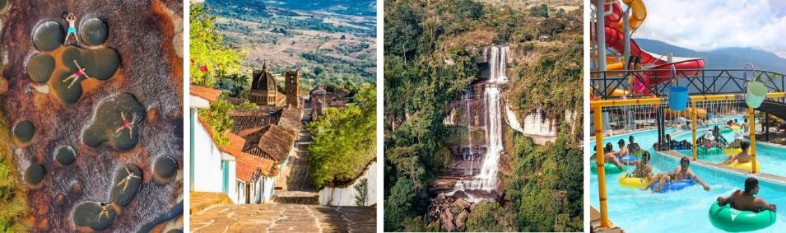

PLAN INCLUDES:

- Accommodation at Hotel Hacienda Guane (1 night)
- Accommodation at Hotel La Quinta del Muelle (2 nights)
- Taxes and hotel insurance
- Round-trip transportation from Bogotá or Tunja
- Meals: 4 breakfasts, 3 dinners
- Visit to Las Gachas (Guadalupe)
- Visit to the Cascada de los Caballeros waterfall (San José de Suaita)
- Visit to El Socorro (heritage town)
- Entrance to El Gallineral Park (San Gil)
- Tour of Barichara
- Entrance to Chicamocha National Park (PANACHI)
- (Includes cable car)
- Entrance to Acuaparque
- Rafting on the Fonce River
- Travel coordinator.
- Professional local guide
- Medical assistance

NOT INCLUDED

- Expenses not specified in the program

ITINERARY
Day 0

- Our departure is one day before the scheduled date.
- 11:00 pm departure to the municipality of Oiba. Meeting point: Maloka, southeast side, opposite the pedestrian traffic light at the Salitre Plaza shopping center. The trip takes approximately 8 hours.
- Seats on the bus will be assigned according to the arrival of passengers and will be for the entire trip.

Day 1

- 6:00 a.m. Arrival in the municipality of Oiba, breakfast.
- Transfer to Cascada de las Gachas and Cascada de los Caballeros.
- 12:30 p.m. Lunch (at each passenger's expense)
- Transfer to the hotel in Oiba, check-in.
- 7:00 p.m. Dinner.

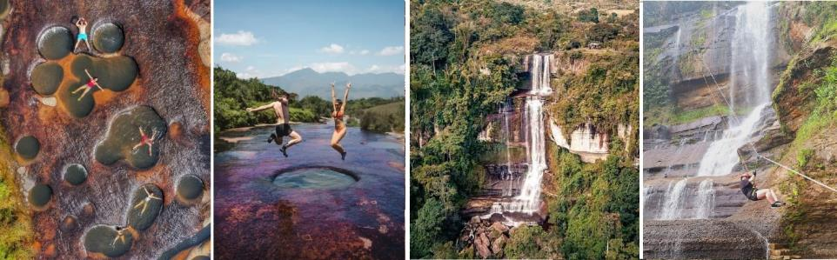

Day 2

- 7:00 – 8:00 am Breakfast. Check out.
- Transfer to the town of Socorro, tour with professional guide, and breakfast.
- Transfer to San Gil and entrance to El Gallineral Park, tour of the park
- 12:30 pm Lunch (at each passenger's expense)
- Transfer to the town of Barichara, tour of Barichara, transfer to the hotel, check-in.
- 7:00 pm Dinner.

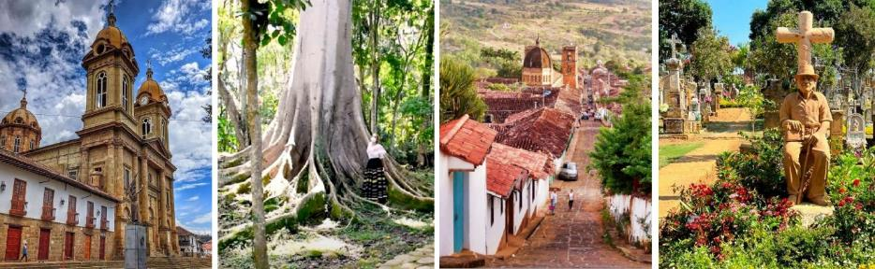

Day 3
- 7:30 - 8:15 a.m. Breakfast.
- 8:30 a.m. Departure to Chicamocha National Park and Water Park.
- 12:30 p.m. Lunch (at each passenger's expense)
- 6:00 p.m. Return to the hotel.
- 7:00 p.m. Dinner at the hotel.

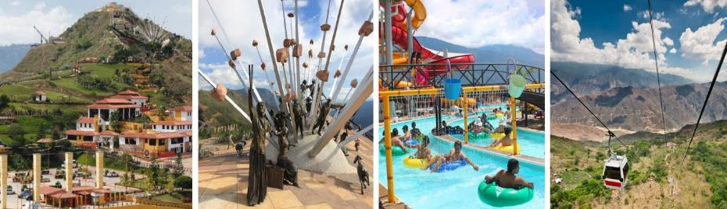

Day 4
- 7:30 - 8:15 a.m. Breakfast, 8:30 a.m. Rafting on the Fonse River.
- Return to the hotel and check out.
- 12:00 p.m. Lunch on the road, return to our city of origin.
- Conditions and restrictions apply. Itinerary subject to change before or during the tour due to factors beyond our control.

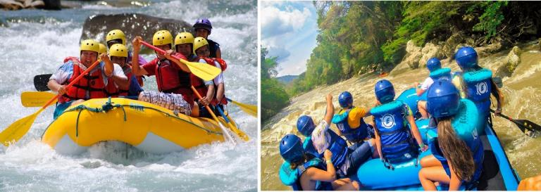

RATES PER PERSON
MULTIPLE | DBL | SGL | KIDS  (3 a 8 ) | INFANT  (0 a 2 )
$ 282 | $298 | $353 | $271 | $27

RECOMMENDATIONS DURING THE TOUR

To ensure you enjoy your experience to the fullest on this tour, we would like to share the following recommendations:

We must bring good social skills, a strong desire to travel, a thirst for knowledge, a pinch of curiosity, a teaspoon of planning, the ability to overcome resistance to discovering new places, and a large dose of improvisation.

- Comfortable, breathable clothing.
- Preferably quick-drying garments.
- A change of clothes for after water activities.
- A comfortable backpack with two straps to carry on your back.
- Bring essentials such as cash and a cell phone.
- Bring sunscreen.
- Bring a cap or hat.
- Bring an umbrella in case of rain.
- For Chicamocha National Park, we suggest bringing a swimsuit and towel. In the pool area, wear non-slip shoes whenever possible to avoid accidents.
- Comfortable shoes (sneakers) that hopefully protect your ankles.
- Bring water to stay hydrated along the way.
- To go to Las Gachas, we recommend bringing a pair of old socks.
- To contribute to the conservation of the environment, we recommend keeping your trash in a bag.

