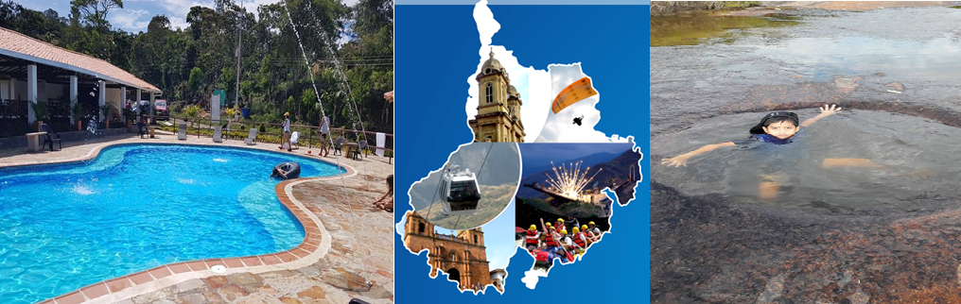
DISCOVERING SANTANDER 4N/5D

Hotel Bucaramanga | Touristic kind
Hotel at Oiba | Hotel hacienda Guane  Campestre  Located in Oiba
Hotel at San Gil | Hotel Terrazas de la Candelaria  Located in San Gil

PLAN INCLUDES:

- Accommodation at the Hotel de Bucaramanga (1 night)
- Accommodation at the Hotel Hacienda Guane (2 nights)
- Accommodation at the Hotel de San Gil in a country hotel (1 night)
- Taxes and hotel insurance
- Airport–hotel–airport transfer (permanent transport)
- Transfer from Chicamocha National Park to Hotel San Gil or Barichara in white-plated transport
- Breakfasts at the hotel, dinners
- City Night Tour – Cerro El Santísimo.
- Tour Crossing the Chicamocha
- Tour San Gil, Barichara, Curití
- Tour Socorro, Valle San José, Pinchote
- Entrance to El Gallineral Park
- Tour to Oiba Guadalupe and Las Gachas
- Medical assistance

NOT INCLUDED

- Expenses not specified in the program

ITINERARY

Day 1

- Airport Transfer – Hotel – We suggest (Arrival must be before 2 PM.)
- Visit to San Francisco shoe district and parks of Bucaramanga
- City Night Tour, transportation throughout, tour guide, visit to Girón National Monument, visit to Floridablanca, admission to Ecoparque, cable car ride up Cerro El Santísimo, visit to the longest cable-stayed bridge in South America
- Dinner
- Accommodation in Bucaramanga

Day 2

- Breakfast at the hotel.
- Leave your luggage at the hotel reception in Bucaramanga. For your convenience, we will collect it and take it to the hotel in San Gil. Only take what you need for the day on the tour.
- Tour crossing Chicamocha (Departure: Hotel lobby, visit to the farmers' market in Mesa de los Santos, entrance to Chicamocha National Park via the “Plazuela” station, total cable car ride of 6.3 km where you can observe the wonderful canyon, tour of the park facilities. 1 cable car ride).
- Departure for Oiba, approximately 3:30 pm
- Visit and tour of CURITI “ARTESANÍAS EN FIQUE” (FIQUE CRAFTS)
- Dinner
- Accommodation at Hotel Hacienda Guane.

Day 3

- Breakfast at the hotel
- Visit and admission to LAS GACHAS NATURAL ATTRACTION
- Visits and sightseeing tours of GUADALUPE and its churches.
- Visit to Oiba, the nativity scene village
- Visit to Socorro, the community capital
- Dinner
- Accommodation at Hotel Hacienda Guane.

Day 4

- Breakfast at the hotel
- Sightseeing tour of PINCHOTE, birthplace of heroine Antonia Santos
- Visit to El Gallineral Park in San Gil
- Sightseeing tour of VALLE DE SAN JOSÉ
- Tasting of “CHORIZO DOÑA EUSTAQUIA”
- Visit Barichara, the most beautiful village in Colombia.
- Dinner
- Accommodation in San Gil.

Day 5

- Breakfast
- Day Off to enjoy the hotel
- Hotel-airport transfer (we suggest that the return flight be after 3 pm)

RATE PER PERSON
HOTEL | MULTIPLE | DBL | SGL | KIDS  (5 a 10)
TOURIST | $287 | $340 | $419 | $261
SUPERIOR | $366 | $419 | $498 | $340
*All departures are shared (excursion type)*

INFANT RATE
AGE | PRICE | INCLUDES
0 a 2 | $ 8 | Medical Assistance
3 a 4 | $ 56 | Medical assistance, attraction tickets, and transportation
*Infant fare NOT commissionable *

RECOMMENDATIONS DURING THE TOUR

To ensure you enjoy your experience to the fullest on this tour, we would like to share the following recommendations with you:

- Bring sunscreen
- Bring a cap or hat
- Bring cool clothing and comfortable shoes
- Bring a swimsuit to enter the water park
- Bring a change of clothes (rappel activity) (additional cost)
- Driver's license to enter the buggies (additional cost)
- Bring a camera
- Bring water
- To help preserve the environment, we recommend disposing of waste in a trash can

HOTELS
