DISCOVER THE COMMUNAL PROVINCE 2N/3D

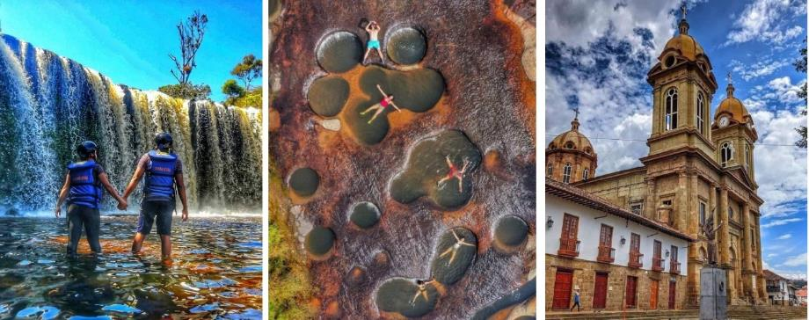

PLAN INCLUDES:

- Accommodation at the Hacienda Guane Hotel (2 nights)
- Taxes and hotel insurance
- Round-trip transportation from Bogotá or Tunja
- Meals: 3 breakfasts, 2 dinners
- Visit to Las Gachas (Guadalupe)
- Visit to Suita – Cotton Museum
- Visit to Los Caballeros Waterfall (San José de Suaita)
- Visit to El Socorro (Heritage Town)
- Visit to the Nitro Cave (Caving)
- Visit to Oiba (Nativity Scene Village)
- Visit to La Humeadora Waterfall (Gambita)
- Travel coordinator.
- Professional local guide
- Medical assistance

NOT INCLUDED

- Expenses not specified in the program

ITINERARY

Day 0

- Our departure is one day before the scheduled date.
- 11:30 pm Departure time. Meeting point to be confirmed. Approximately 6-hour trip to Vado Real.
- Seats on the bus will be assigned according to passenger arrival and will remain the same for the entire trip.

Day 1

- Arrival at Vado Real: Breakfast, morning visit and entrance to the Nitro Cave tour with local guide, safety equipment (helmet and flashlight), recommendation to wear shoes with good grip.
- 12:30 pm Lunch (at each passenger's expense)
- 2:00 pm Visit and entrance to La Humeadora waterfall tour with local guide, safety equipment (helmet, vest). Wear shoes with good grip. In the afternoon, arrival at the hotel, accommodation, and dinner.

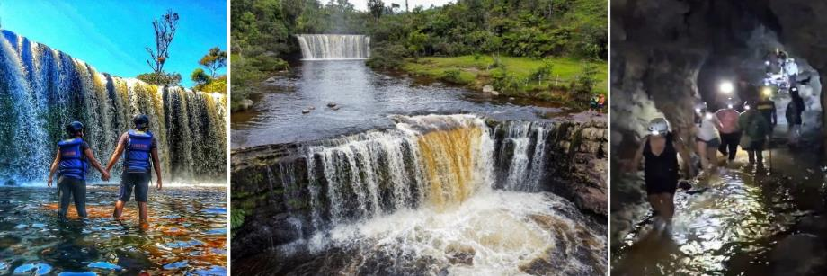

Day 2

- Breakfast, morning visit and entrance to Las Gachas with local guide, bring socks for the activity.
- 12:30 pm Lunch (at each passenger's expense)
- 1:30 pm Visit and entrance to Los Caballeros waterfall, bring shoes with good grip. Visit and entrance to the Cotton Museum, dinner.

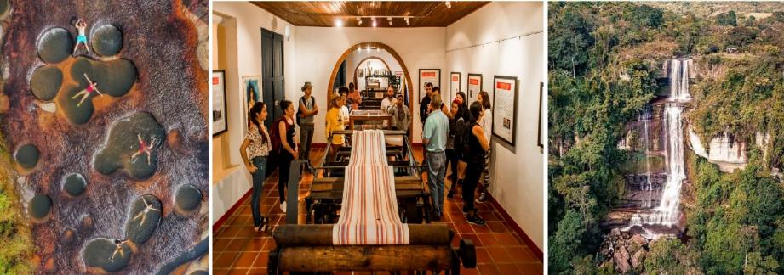

Day 3

- Breakfast, 8:00 a.m. Check out, departure from the hotel, visit to the town of Oiba, visit to the town of Socorro, cultural tour with local guide.
- 12:30 p.m. Lunch (at each passenger's expense)
- 2:00 p.m. Visit and admission to the Orchids.
- Return to our city of origin, end of our services.
- Conditions and restrictions apply. Itinerary subject to change before or during the tour due to factors beyond our control.

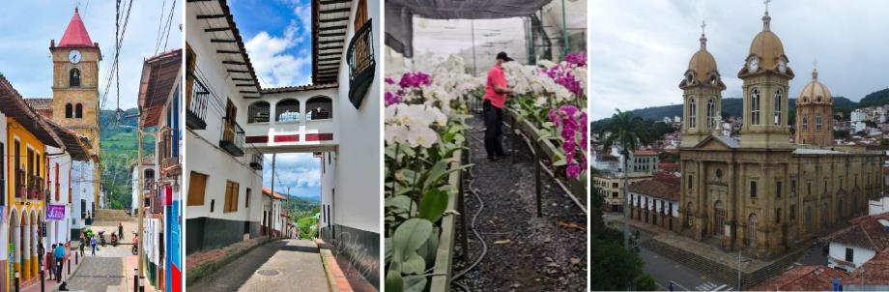

RATES PER PERSON
 | MULTIPLE | DBL | KIDS  (3 a 8 ) | INFANT  (0 a 2 )
$ 182 |  | $ 200 | $ 170 | $ 27

RECOMMENDATIONS DURING THE TOUR

To help you enjoy your experience to the fullest on this tour, we would like to share the following recommendations:

We must bring good social skills, a strong desire to travel, a thirst for knowledge, a pinch of curiosity, a teaspoon of planning, the ability to overcome our reluctance to discover new places, and a large dose of improvisation.

- Comfortable, breathable clothing.
- Preferably quick-drying garments.
- A change of clothes for after water activities.
- A comfortable backpack with two straps to carry on your back.
- Bring essentials such as cash and a cell phone.
- Bring sunscreen.
- Bring a cap or hat.
- Bring an umbrella in case of rain.
- Comfortable footwear (sneakers) that hopefully protects the ankle.
- Bring water to stay hydrated along the way.
- To go to Las Gachas, we recommend bringing a pair of old socks.
- To contribute to the conservation of the environment, we recommend storing your waste in a bag.

