DISCOVERING THE COMMUNAL PROVINCE 4N / 5D
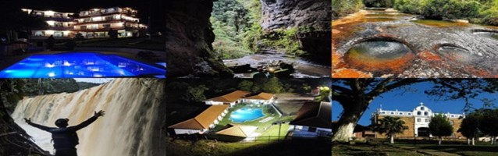
Departure from Bogotá at 1 a.m.
PLAN INCLUDES:
- Accommodation at the María Fernanda Hotel in Gambita (1 night)
- Accommodation at the Hacienda Guane Hotel in Oiba (2 nights)
- Accommodation at Hotel Emporio Natural and/or Las Orquídeas de Guapota (1 night)
- Taxes and hotel insurance
- 5 breakfasts
- 4 dinners
- 5 lunches
- Medical assistance

NOT INCLUDED

- Expenses not specified in the program

ITINERARY
Day 1
- Departure from Bogotá at 1 a.m.
- Breakfast en route.
- From Boyacá, just 2.8 km from the rugged lands of Santander,
- Gambita.
- Enjoy the village of La Palma
- The impressive Choco Cave (optional rappelling) will be among the activities to be carried out. We are sure that they will leave an indelible mark on all of your souls.
- Lunch
- Visit the Manto de la Virgen Waterfall viewpoint (optional climb to the canyon of La Hondura)
- Check in at Hotel María Fernanda
- Visit Dinner and enjoy the hotel.

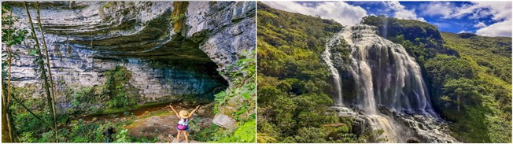

Day 2
- Breakfast - Check out
- Experience at La Humeadora waterfall in Gambita.
- Lunch
- Visit to Nitro Cave – Caving experience
- Dinner
- Accommodation in Oiba
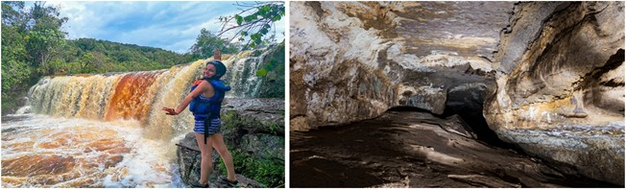

Day 3
- Breakfast.
- Departure for Suaita.
- Visit to the main park.
- Visit to the museum and cotton factories in San José de Suaita.
- Lunch.
- Visit to the Villa de los Caballeros waterfall.
- Experience in the natural hot springs “Quebrada las Gachas.”
- Visit to the town center of Guadalupe.
- Return to the hotel
- Dinner
- Accommodation in Oiba

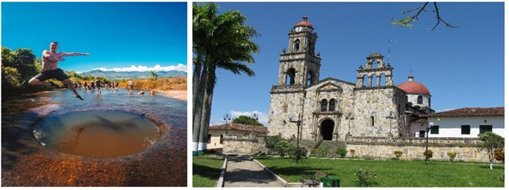

Day 4
- Breakfast at the hotel.
- El Socorro, “Capital of the Comunera Confederation of Colombia”—Cradle of American Independence—Heritage Town of Colombia, awaits us.
- Lunch.
- Tourist sites in Guapota, waterfall, and natural slides of Guapota.
- Accommodation in Guapota.
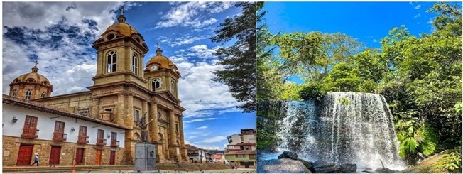

Day 5
- Breakfast at the hotel
- Enjoy the hotel
- Lunch
- Return to Bogotá

RATES PER PERSON
MULTIPLE | DBL
$ 316 | $ 343

*Rate valid for groups of at least 12 people * *Departures every week from Bogotá*
*All services additional to accommodation will be operated directly by the agency.* *Rates subject to availability and change without prior notice. *
*All departures are regular (excursion type)

