SIGHTSEEING SANTANDER 5N/6D
COMBINED
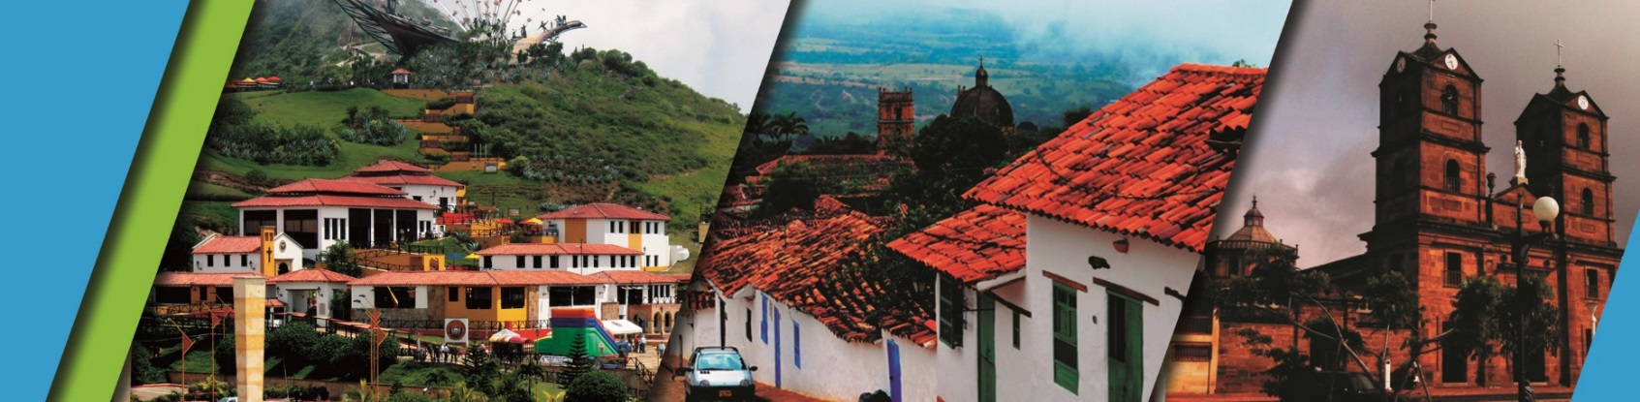

PLAN INCLUDES:

- Accommodation at the Hotel in Bucaramanga (3 nights)
- Accommodation at the Hotel in San Gil or Barichara (2 nights)
- Taxes and hotel insurance
- Airport–hotel–airport transfer
- Chicamocha National Park–San Gil or Barichara hotel transfer transport
- Breakfasts at the hotel, dinners, lunches
- City Night Tour – Cerro El Santísimo (regular departure – park closed on Mondays)
- Tour Crossing the Chicamocha (regular departure - Park is closed on Mondays and Tuesdays)
- San Gil Tour, Barichara Tour, Curití Tour (regular departure)
- Socorro Tour, Valle San José Tour, Pinchote Tour (regular departure)
- Zapatoca Tour (regular departure)
- Medical assistance

NOT INCLUDED

- Expenses not specified in the program

ITINERARY

Day 1

- Transfer Airport – Hotel
- City Night Tour (Departure: Hotel Lobby, Permanent Transportation, Tour Guide, Travel Insurance,
- Visit to Girón National Monument,
- Visit to Floridablanca, local snack Tasting, Entrance to Ecopark, Cable Car Ride to Cerro El Santísimo, visit to the tallest Cable-Stayed Bridge within a city in Colombia)
- Dinner
- Accommodation in Bucaramanga

Day 2

- Breakfast at the hotel.
- Leave your luggage at the hotel reception in Bucaramanga. For your convenience, we will collect it and take it to the hotel in San Gil or Barichara. Only take what you need for the day on the tour.
- Tour crossing Chicamocha (Departure: Hotel lobby, visit to the farmers' market in Mesa de los Santos, refreshments, Entrance to Chicamocha National Park via the “Plazuela” station, total cable car ride 6.3 km (one way) where you can observe the wonderful canyon, tour of the park facilities, and typical regional lunch).
- Departure for San Gil or Barichara, approximately 3:30 pm
- Dinner
- Accommodation in San Gil or Barichara.

Day 3

- Breakfast at the hotel
- Visit and tour of CURITI
- Visit and admission to EL GALLINERAL NATURAL PARK
- Transfer to BARICHARA
- Lunch in BARICHARA
- Visits and sightseeing tours of BARICHARA and its churches
- Dinner
- Accommodation in San Gil or Barichara.

Day 4

- Breakfast at the hotel
- Sightseeing tour of SOCORRO
- Sightseeing tour of PINCHOTE, home of Antonia Santos
- Lunch
- Sightseeing tour of VALLE DE SAN JOSÉ
- Tasting of “CHORIZO DOÑA EUSTAQUIA”
- Dinner
- Accommodation in Bucaramanga
Day 5

- Breakfast
- Crossing the 500-meter-long Gómez Ortiz Bridge over the Hidrosogamoso Dam. Tourist route “La Ciudad Levítica” (The Levitical City), entrance to the Church of San Joaquín
- Entrance to the “CASA DE EJERCICIOS,” entrance to the “COSMOS MUSEUM.”
- Lunch
- Visit to the “MIRADOR GUANE” viewpoint, visit to the “CAMPO SANTO y TUMBA DE GEO VON LENGERKE” cemetery and tomb, visit to the “CUEVA DEL NITRO” cave.
- Dinner
- Accommodation in Bucaramanga

Day 6

- Breakfast
- Day off
- Transfer Hotel – Airport

RATE PER PERSON
HOTEL | MULTIPLE | DBL | SGL | KIDS  (5 to10)
TOURIST | $474 | $553 | $842 | $356
SUPERIOR | $524 | $606 | $956 | $392
LUXURY SUPERIOR | $619 | $685 | $1210 | $487

INFANT RATE
AGE | PRICE | INCLUDES
0 a 2 | $10 | Medical Assistance
3 a 4 | $61 | Medical assistance, attraction tickets, and transportation

*Dinner with a glass of wine applies to SUPERIOR and SUPERIOR DELUXE accommodations*
*Exclusive transportation supplement for 1-4 people: $1,300,000*
*All departures are regular (excursion type)*
*All services additional to accommodation will be operated directly by the agency.*
*Infant rate is NOT commissionable*
RECOMMENDATIONS DURING THE TOUR

To ensure you enjoy your experience to the fullest on this tour, we would like to share
the following recommendations with you:

Bring sunscreen
Bring a cap or hat
Bring cool clothing and comfortable shoes
Bring a swimsuit to enter the water park
Bring a change of clothes for after rappel (additional cost)
Driver's license to enter the buggies (additional cost)
Bring a camera.
Bring water.
To help preserve the environment, we recommend disposing of waste in a trash can.

HOTELS

