SANTANDER TRIP 3N/4D
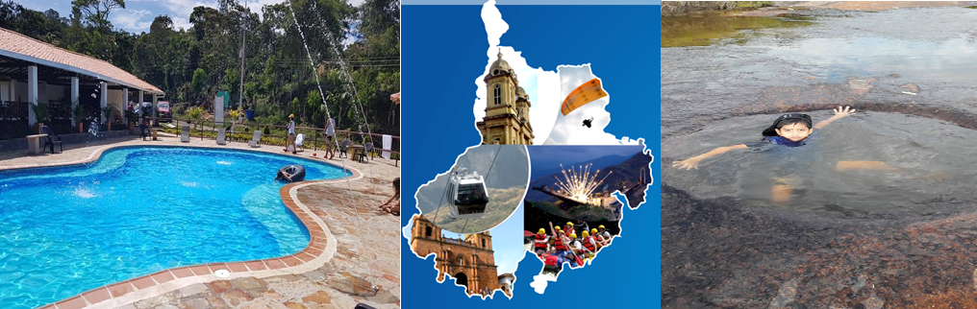

HOTELS
Hotel at Oiba  Or Guadalupe | Hotel Hacienda Guane Campestre  Located in Oiba
Hotel at San Gil | Hotel Terrazas de la Candelaria  Located in San Gil

PLAN INCLUDES:

- Accommodation at Hotel Hacienda Guane (2 nights)
- Accommodation at Hotel de San Gil in a country hotel (1 night)
- Taxes and hotel insurance
- Airport–hotel–airport transfer (permanent transport)
- Transfer from Chicamocha National Park to Hotel San Gil or Barichara
- Breakfasts at the hotel, dinners
- Tour crossing the Chicamocha
- Tour of San Gil, Barichara, Curití
- Tour of Socorro, Valle San José, Pinchote
- Entrance to El Gallineral Park
- Tour to Oiba Guadalupe and Las Gachas
- Medical assistance

NOT INCLUDED

- Expenses not specified in the program

ITINERARY

Day 1

- Airport – Hotel Transfer, suggested (Arrival must be before 7 AM)
- Tour Crossing Chicamocha (Departure: Hotel Lobby, visit to the Farmers Market in Mesa de los Santos, Entrance to Chicamocha National Park via the “Plazuela” Station, total cable car rides of 6.3 km where you can observe the wonderful canyon, Total tour of the park facilities. 1 cable car ride).
- Departure for Guadalupe, approximately 3:30 pm
- Visit and tour of CURITI “ARTESANÍAS EN FIQUE” (FIQUE HANDICRAFTS)
- Dinner
- Accommodation at Hotel Hacienda Guane

Day 2

- Breakfast at the hotel
- Visit and admission to LAS GACHAS NATURAL ATTRACTION
- Visits and sightseeing tours of GUADALUPE and its churches.
- Visit to Oiba, the nativity scene village
- Visit to Socorro, the community capital
- Dinner
- Accommodation at Hotel Hacienda Guane

Day 3

- Breakfast at the hotel
- Sightseeing tour of PINCHOTE, birthplace of heroine Antonia Santos
- Visit to El Gallineral Park in San Gil
- Sightseeing tour of VALLE DE SAN JOSÉ
- Tasting of “CHORIZO DOÑA EUSTAQUIA”
- Visit to Barichara, the most beautiful village in Colombia.
- Dinner
- Accommodation in San Gil.

Day 4

- Breakfast
- Day off to enjoy the hotel
- Hotel-airport transfer (we suggest that the return flight be after 3 pm)

RATE PER PERSON
HOTEL | MULTIPLE | DBL | SGL | KIDS  (5 a 10)
TOURIST | $261 | $287 | $366 | $235
*All departures are shared (excursion type)*

CHILDREN FARE
AGE | PRICE | INCLUDE
0 a 2 | $ 8 | Medical Assistance
3 a 4 | $ 79 | Medical assistance, attraction tickets, and transportation
*Infant fare NOT commissionable*

RECOMMENDATIONS DURING THE TOUR

To ensure you enjoy your experience to the fullest on this tour, we would like to share the following recommendations with you:

- Bring sunscreen
- Bring a cap or hat
- Bring cool clothing and comfortable shoes
- Bring a swimsuit to enter the water park
- Bring a change of clothes for after canyoning (additional cost)
- Driver's license to enter the buggies (additional cost)
- Bring a camera
- Bring water
- To help preserve the environment, we recommend disposing of waste in a trash can.

