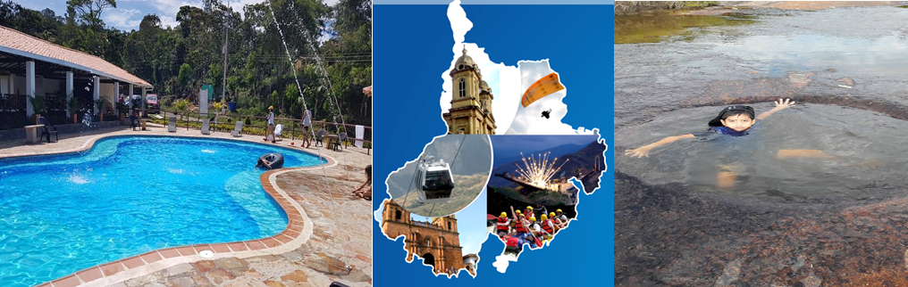
FLIGHT PLAN - SANTANDER 4N/5D

PLAN INCLUDES:

- Direct flights on Mondays, Medellín – San Gil, Bogotá – San Gil
- Round-trip airfare
- Accommodation at the Terrazas de San Gil Hotel (3 nights)
- Accommodation at the Hacienda Guane Campestre Hotel or Terrazas de Guadalupe Hotel (1 night)
- Taxes and hotel insurance
- Transfer to Chicamocha National Park in white-plated transport
- Breakfasts at the hotel and dinners.
- Tour of San Gil, Barichara, Curití
- Tour of Socorro, Valle San José, Pinchote
- Entrance to El Gallineral Park and Juan Curí Waterfalls
- Tour to Oiba Guadalupe and Las Gachas
- Medical assistance

NOT INCLUDED

- Expenses not specified in the program
- Lunches during the plan

ITINERARY

Day 1 - Monday

- Transfer from San Gil Airport to Hotel Terrazas de San Gil.
- Day off to enjoy the hotel facilities.
- Dinner at the hotel.

Day 2 - Tuesday

- Breakfast at the hotel.
- Departure at 7:30 a.m.
- Sightseeing tour of Barichara, Colombia's most beautiful village, known for its cobblestone streets and colonial architecture.
- Tour and entrance to Gallineral Park in San Gil, where you will find cobblestone paths, wildflowers, heliconias, and colonial bridges that invite visitors to walk and enjoy the fresh, romantic atmosphere.
- Sightseeing tour of the San José Valley.
- Tour of the municipality of El Paramó.
- Sightseeing tour of Pinchote, birthplace of the heroine Antonia Santos.
- Lunch on your own (each person buys their own lunch).
- Dinner at the hotel.
- Accommodation at Hotel Terrazas de San Gil.

Day 3 – Wednesday

- Breakfast at the hotel.
- Departure: 7:30 a.m.
- Sightseeing tour of Curití, “the weavers' village”: an important municipality located in the province of Guanentá, renowned for its landscape and beautiful woven crafts made from fique fiber.
- Tour of ECOFIBRAS, a company dedicated to keeping alive the textile tradition inherited from the Guane indigenous culture.
- Lunch on your own (each person buys their own lunch).
- Tour and admission to CHIMAMOCHA NATIONAL PARK (includes park admission, two round-trip cable car rides, Acuaparque admission)
- Dinner at the hotel
- Accommodation at Hotel Terrazas de San Gil.

Day 4 - Thursday

- Breakfast at the hotel.
- Departure at 7:30 a.m. with your luggage.
- Visit to Socorro (heritage town)
- Visit and entrance to LAS GACHAS NATURAL ATTRACTION.
- Lunch on your own (each person buys their own lunch).
- Visits and sightseeing tours of GUADALUPE and its churches.
- Visit to Oiba, a small nativity scene village
- Dinner at the hotel
- Accommodation at Oiba (Hotel Hacienda Guane or Terrazas de Guadalupe)

Day 5 - Friday

- Breakfast at the hotel
- Departure with luggage
- Transfer to San Gil Airport

RATE PER PERSON
HOTEL | DBL | MULTIPLE | KIDS  (5 a 10 )
TOURIST | $487 | $461 | $422
*All departures are shared (excursion type)*

INFANT RATE
AGE | PRICE | INCLUDES
0 a 2 | $ 8 | Medical Assistance
3 a 4 | $ 56 | Medical assistance, attraction tickets, and transportation
*Infant fare NOT commissionable*

RECOMMENDATIONS DURING THE TOUR

To ensure you enjoy your experience to the fullest on this tour, we recommend the following:

- Bring sunscreen
- Bring a cap or hat
- Wear cool clothing and comfortable shoes
- Bring a swimsuit to enter the water park
- Bring a change of clothes for after rappel (additional cost)
- Driver's license to enter the buggies (additional cost)
- Camera
- Bring water
- To contribute to the conservation of the environment, we recommend depositing waste in a trash can.

