GOING AROUND SANTANDER 4N/5D
COMBINED
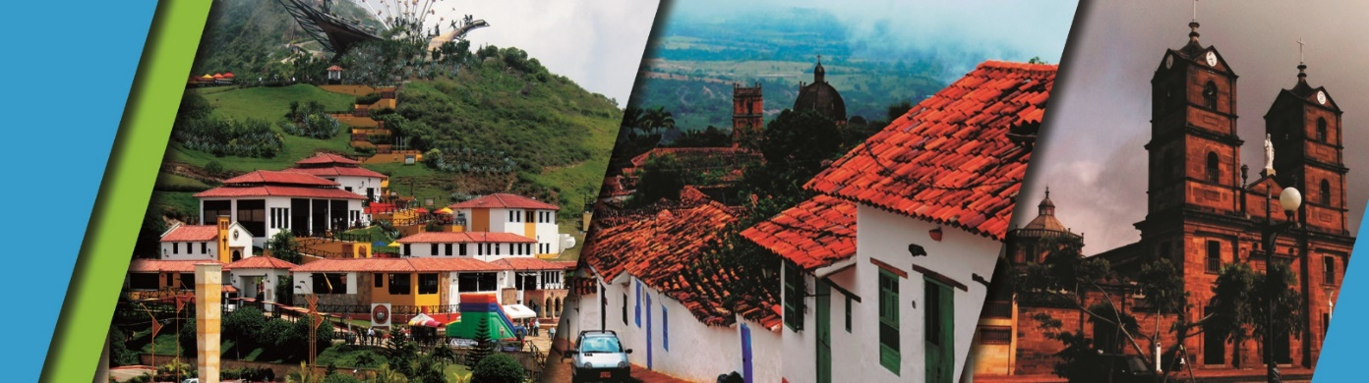

PLAN INCLUDES:

- Accommodation at the Hotel in Bucaramanga (2 nights)
- Accommodation at the Hotel in San Gil or Barichara (2 nights)
- Taxes and hotel insurance
- Airport–hotel–airport transfer
- Chicamocha National Park–San Gil or Barichara hotel transfer in white-plated transport
- Breakfasts at the hotel, dinners, lunches
- City Night Tour – Cerro El Santísimo (regular departure – park closed on Mondays)
- Tour Crossing the Chicamocha (regular departure - park is closed on Mondays and Tuesdays)
- Tour San Gil, Tour Barichara, Tour Curití (regular departure)
- Tour Socorro, Tour Valle San José, Tour to Pinchote (regular departure)
- Medical assistance

NOT INCLUDED

- Expenses not specified in the program

ITINERARY

Day 1

- Airport Transfer – Hotel
- City Night Tour (Departure: Hotel Lobby, Permanent Transportation, Tour Guide, Travel Insurance
- Visit to Girón National Monument
- Visit to Floridablanca, local Snack Tasting, Entrance to Ecopark, Cable Car Ride to Cerro El Santísimo
- Visit to the tallest Cable-Stayed Bridge within a city in Colombia
- Dinner
- Accommodation in Bucaramanga

Day 2

- Breakfast at the hotel.
- Leave your luggage at the hotel reception in Bucaramanga. For your convenience, we will collect it and take it to the hotel in San Gil or Barichara. Take only what you need for the day on the tour.
- Tour crossing Chicamocha (Departure: Hotel lobby, visit to the farmers' market in Mesa de los Santos, refreshments, Entrance to Chicamocha National Park via the “Plazuela” station, total cable car ride 6.3 km (1 cable car ride) where you can observe the wonderful canyon, total tour of the park facilities and typical regional lunch).
- Departure for San Gil or Barichara, approximately 3:30 pm
- Dinner
- Accommodation in San Gil or Barichara.

Day 3

- Breakfast at the hotel
- Visit and tour of CURITI
- Visit and admission to EL GALLINERAL NATURAL PARK
- Transfer to BARICHARA
- Lunch in BARICHARA
- Visits and sightseeing tours of BARICHARA and its churches
- Dinner
- Accommodation in San Gil or Barichara
Day 4

- Breakfast at the hotel
- Sightseeing of SOCORRO
- Sightseeing of PINCHOTE, home of Antonia Santos
- Lunch
- Sightseeing of VALLE DE SAN JOSÉ
- Tasting of “CHORIZO DOÑA EUSTAQUIA”
- Dinner
- Accommodation in Bucaramanga

Day 5

- Breakfast
- Day Off (Optional City Tour or Shopping Tour per person $27 dollars)
- Hotel-airport transfer

RATE PER PERSON
HOTEL | MULTIPLE | DBL | SGL | KIDS  (5 a 10)
TOURIST | $366 | $453 | $745 | $287
SUPERIOR | $435 | $498 | $798 | $332
LUXURY SUPERIOR | $516 | $619 | $1023 | $422
INFANT FARE
AGE | PRICE | INCLUDES
0 a 2 | $ 8 | Medical Assistance
3 a 4 | $ 56 | Medical assistance, attraction tickets, and transportation

*Dinner with a glass of wine applies to SUPERIOR and SUPERIOR DELUXE accommodation categories*
*Exclusive transportation supplement for 1-4 people: $1,000,000*
*When the 4-night Puebliando por Santander Plan coincides with a long weekend, the first two nights are in San Gil/Barichara and the last two in Bucaramanga*
*All departures are regular (excursion type)*
*Infant fare NOT commissionable*

RECOMMENDATIONS DURING THE TOUR

To ensure you enjoy your experience to the fullest on this tour, we would like to share the following recommendations with you:

- Bring sunscreen
- Bring a cap or hat
- Bring cool clothing and comfortable shoes
- Bring a swimsuit to enter the water park
- Bring a change of clothes (rappel activity) (additional cost)
- Driver's license to enter the buggies (additional cost)
- Bring a camera
- Bring water
- To help preserve the environment, we recommend disposing of waste in a trash can.

HOTELS

