VISITING SANTANDER 3N/4D
RUSH OF ADRENALINE

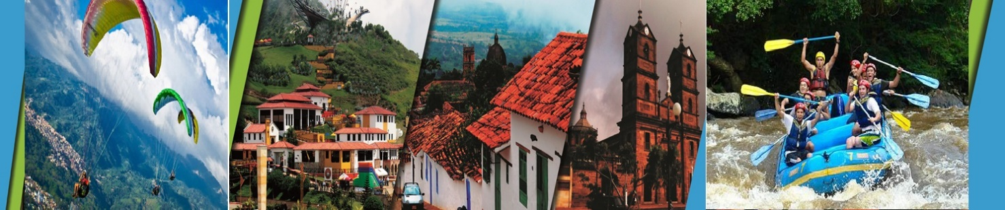

PLAN INCLUDES:

- Accommodation at the Hotel in Bucaramanga (1 night)
- Accommodation at the Hotel in San Gil or Barichara (2 nights)
- Taxes and Hotel Insurance
- Airport – Hotel – Airport Transfer
- Transfer from Chicamocha National Park to Hotel San Gil or Barichara in white-plated transport
- Breakfast at the hotel
- Dinners
- Lunches
- City Night Tour – Cerro Del Santísimo (regular departure)
- Paragliding in Ruitoque.
- Tour Crossing the Chicamocha (Regular departure)
- San Gil Tour (Regular departure)
- Rafting
- Trekking (14 Activities).
- Visit to Curití (Regular departure)
- Barichara Tour (Regular departure)
- Medical assistance

NO INCLUYE

- Expenses not specified in the program

ITINERARY

Day 1

- Airport – Hotel Transfer
- Paragliding at Voladero de Ruitoque
- City Night Tour (Departure: 3:30 pm Hotel Lobby, permanent transportation, Tour Guide, Travel Insurance, visit to Girón National Monument, visit to Floridablanca, local snack tasting, entrance to the Ecopark, cable car ride to Cerro El Santísimo
- Visit to the tallest cable-stayed bridge within a city in Colombia
- Dinner
- Accommodation in Bucaramanga

Day 2

- Breakfast at the hotel.
- Leave your luggage at the hotel reception in Bucaramanga. For your convenience, we will collect it and take it to the hotel in San Gil or Barichara. Bring only what you need for the day on the tour.
- Tour Crossing Chicamocha (Departure: 7:45 a.m. Hotel lobby, visit to the farmers' market in Mesa de los Santos, refreshments, entrance to Chicamocha National Park via the “Plazuela” station, 6.3 km cable car ride where you can see the wonderful canyon, tour of the park facilities, and typical regional lunch).
- Departure for San Gil or Barichara, approximately 3:30 pm
- Visit and tour of CURITI “ARTESANÍAS EN FIQUE” (FIQUE HANDICRAFTS)
- Dinner
- Accommodation in San Gil or Barichara

Day 3

- Breakfast at the hotel
- Canoeing practice
- Lunch
- Trekking (14 activities)
- Dinner
- Accommodation in San Gil or Barichara

Day 4

- Breakfast at the hotel
- Visit and admission to EL GALLINERAL NATURAL PARK in San Gil
- Transfer to BARICHARA
- Lunch in BARICHARA
- Visits and sightseeing tours of BARICHARA and its churches
- Hotel-airport transfer

RATE PER PERSON
HOTEL | MULTIPLE | DBL | SGL | KID  (5 a 10 year old)
TOURIST | $337 | $408 | $669 | $285
SUPERIOR | $372 | $432 | $708 | $314
LUXURY SUPERIOR | $424 | $519 | $877 | $356

INFANT FARE
AGE | PRICE | INCLUDE
0 a 2 | $ 6 | Medical assistance
3 a 4 | $ 45 | Medical assistance, attraction tickets, and transportation

*Dinner with a glass of wine applies to SUPERIOR and SUPERIOR DELUXE accommodations.*
*All services additional to accommodations will be operated directly by the agency.*
*Exclusive transportation supplement for 1-4 people: $800,000*
*When the Visiting Santander Plan coincides with a long weekend, all nights in Bucaramanga are confirmed*
*All departures are regular (excursion type)*

*Infant fare NOT commissionable*

RECOMMENDATIONS DURING THE TOUR

To ensure you enjoy your experience to the fullest on this tour, we would like to share the following recommendations with you:

- Bring sunscreen
- Bring a cap or hat
- Bring cool clothing and comfortable shoes
- Bring a swimsuit to enter the water park
- Bring a change of clothes for after the torrentismo (additional cost)
- Driver's license to enter the buggies (additional cost)
- Bring a camera
- Bring water
- To help preserve the environment, we recommend disposing of waste in a trash can.

HOTELS
