VISITING SANTANDER 3N/4D
COMBINED
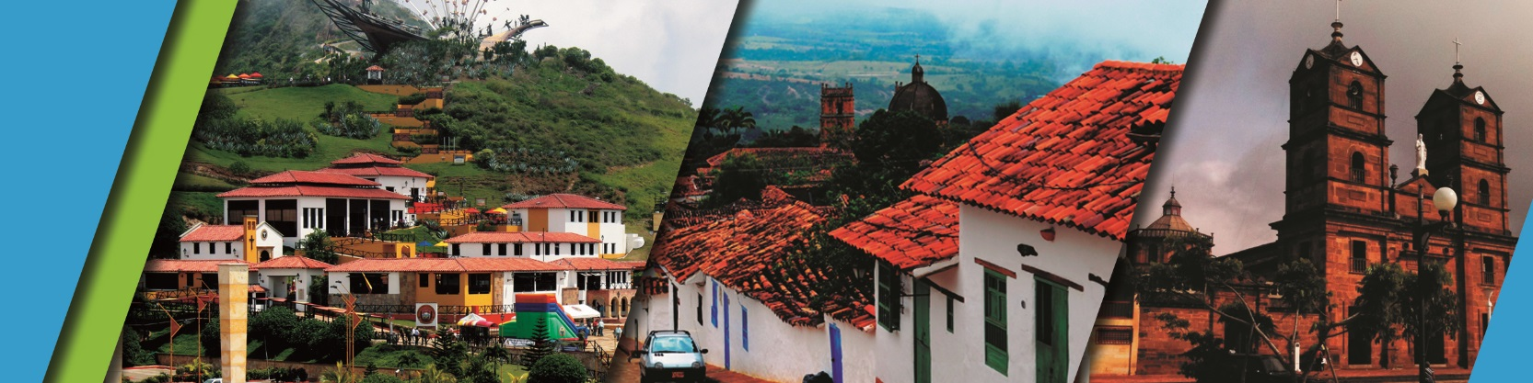

PLAN INCLUDES:

- Accommodation at the Hotel in Bucaramanga (2 nights)
- Accommodation at the Hotel in San Gil or Barichara (1 night)
- Taxes and hotel insurance
- Airport–hotel–airport transfer
- Chicamocha National Park–San Gil or Barichara hotel transfer
- Breakfast at the hotel
- Dinners
- Lunches
- City Night Tour – Cerro Del Santísimo (shared departure)
- Tour Crossing the Chicamocha (shared departure)
- San Gil Tour (shared departure)
- Curití Tour (shared departure)
- Barichara Tour (shared departure)
- Medical assistance

NOT INCLUDED

- Expenses not specified in the program
ITINERARY
Day 1

- Airport Transfer – Hotel
- City Night Tour (Departure: Hotel Lobby, Permanent Transportation, Tour Guide, Travel Insurance
- Visit to Girón National Monument
- Visit to Floridablanca, local snack Tasting, Entrance to Ecopark, Cable Car Ride to Cerro El Santísimo,
- Visit to the tallest Cable-Stayed Bridge within a city in Colombia
- Dinner
- Accommodation in Bucaramanga

Day 2

- Breakfast at the hotel.
- Leave your luggage at the hotel reception in Bucaramanga. For your convenience, we will collect it and take it to the hotel in San Gil or Barichara. Only take what you need for the day on the tour.
- Tour crossing Chicamocha (Departure: Hotel lobby, visit to the farmers' market in Mesa de los Santos, snack, entrance to Chicamocha National Park via the “Plazuela” station, 6.3 km cable car ride where you can see the wonderful canyon, tour of the park facilities, and typical regional lunch)
- Departure for San Gil or Barichara, approximately 3:30 pm.
- Dinner.
- Accommodation in San Gil or Barichara.

Day 3

- Breakfast at the hotel
- Visit and tour of CURITI
- Visit and admission to EL GALLINERAL NATURAL PARK
- Transfer to BARICHARA
- Lunch in BARICHARA
- Visits and sightseeing tours of BARICHARA and its churches
- Dinner
- Accommodation in Bucaramanga

Day 4

- Breakfast at the hotel
- Day off (optional city tour or shopping tour $27 per person)
- Hotel-airport transfer
RATE PER PERSON
HOTEL | MULTIPLE | DBL | SGL | CHILDREN  (5 a 10 years old)
TOURIST | $298 | $356 | $590 | $258
SUPERIOR | $356 | $382 | $629 | $287
LUXURY SUPERIOR | $395 | $493 | $798 | $356

INFANT FARE
AGE | PRICE | INCLUDES
0 a 2 | $6 | Asistencia Médica
3 a 4 | $45 | Asistencia Médica, entradas atractivos y transporte
* Dinner with a glass of wine applies to SUPERIOR AND SUPERIOR DELUXE* accommodation.
*All services additional to accommodation will be operated directly by the agency.*
*Exclusive transportation supplement for 1-4 people: $800,000*
*When the Visiting Santander Plan coincides with a long weekend, all nights in Bucaramanga are confirmed.*
*All departures are regular (excursion type).*

*Infant fare NOT commissionable*

RECOMMENDATIONS DURING THE TOUR

To ensure you enjoy your experience to the fullest on this tour, we would like to share the following recommendations with you:

- Bring sunscreen
- Bring a cap or hat
- Wear cool clothing and comfortable shoes
- Bring a swimsuit to enter the water park
- Bring a change of clothes for after torrentismo (additional cost).
- Driver's license to ride in the buggies (additional cost).
- Camera.
- Bring water
HOTELS
